NH-is-Blooming Observation Instructions
- Each month we will send you an observation “package” which identifies four or five pollinator friendly flowers that we would like you to watch for anywhere you happen to be around NH.
- When you see one of the flowers, record it on the observation sheet by noting the date, town, and whether you saw pollinators on the flowers.
  - If you see other flowers with pollinators, feel free to also record that on the observation sheet.
- At the end of the month, you can send your observation sheet via either email to nh.is.blooming.com or by USPS mail at: NH-is-Blooming, PO Box 250, Gilmanton, NH 03237.
  - We will add it to the NH-is-blooming database soon after we receive it.
  - We are happy to accept the observations in any format that is easy for you!
- Send questions to: nh.is.blooming@gmail.com

NH-is-Blooming August Observation Flowers
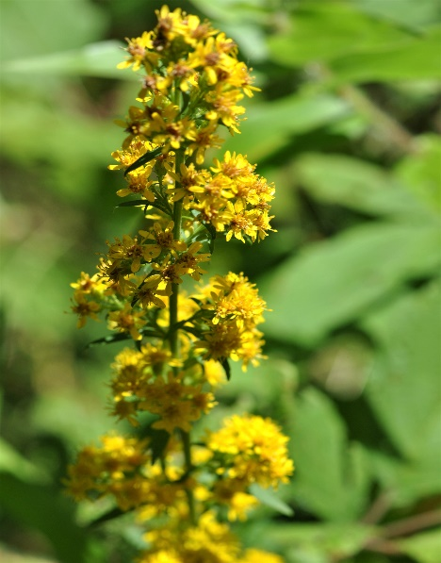
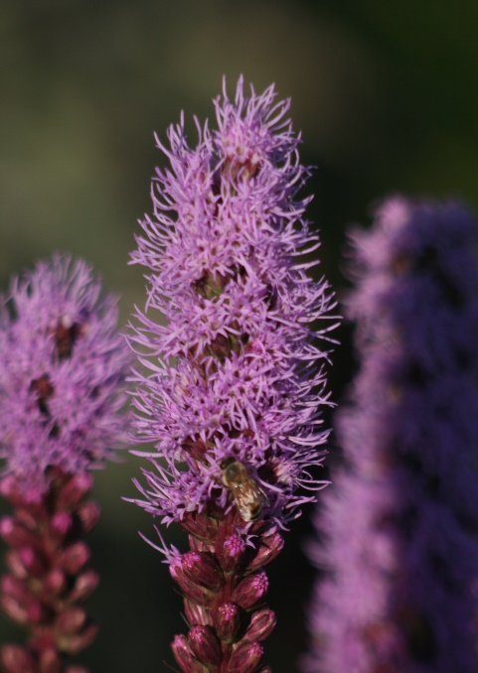

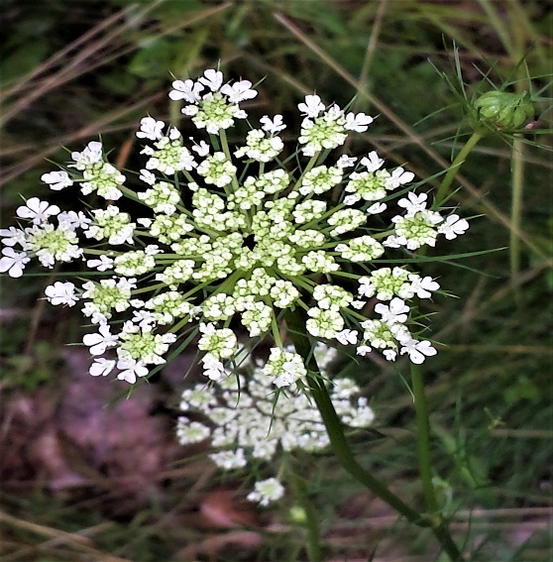
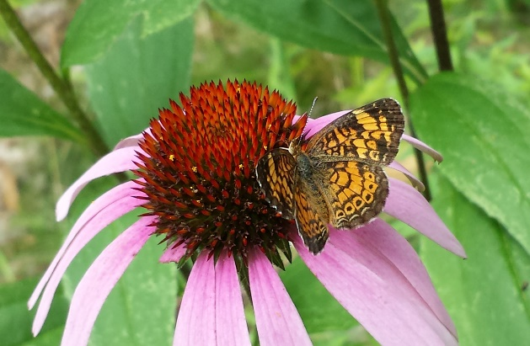
Goldenrod
Description: yellow, slim spike
Pollinators : pollen and nectar source

Source:https://plants.usda.gov/core/profile?symbol=SOLID

Liatris
Description: Tall spike, resembling bottlebrush, purple flowers
Pollinators : pollen and nectar source
Source:https://en.wikipedia.org/wiki/Liatris_spicatahttps://en.wikipedia.org/wiki/Liatris_spicata

Coneflower
Description: Diverse leaf shape, flowers are in whorls, held on spikes.
Pollinators : nectar & pollen source
Source : https://garden.org/plants/group/coneflowers/
Queen Anne’s Lace
Description: lace like flower, sometimes single dark flower in center.
Pollinators : nectar and pollen source
Source:https://www.ediblewildfood.com/queen-annes-lace.aspx

