NH-is-Blooming Observation Instructions
- Each month we will send you an observation “package” which identifies four or five pollinator friendly flowers that we would like you to watch for anywhere you happen to be around NH.
- When you see one of the flowers, record it on the observation sheet by noting the date, town, and whether you saw pollinators on the flowers.
  - If you see other flowers with pollinators, feel free to also record that on the observation sheet.
- At the end of the month, you can send your observation sheet via either email to nh.is.blooming.com or by USPS mail at: NH-is-Blooming, PO Box 250, Gilmanton, NH 03237.
  - We will add it to the NH-is-blooming database soon after we receive it.
  - We are happy to accept the observations in any format that is easy for you!
- Send questions to: nh.is.blooming@gmail.com

NH-is-Blooming June Observation Flowers
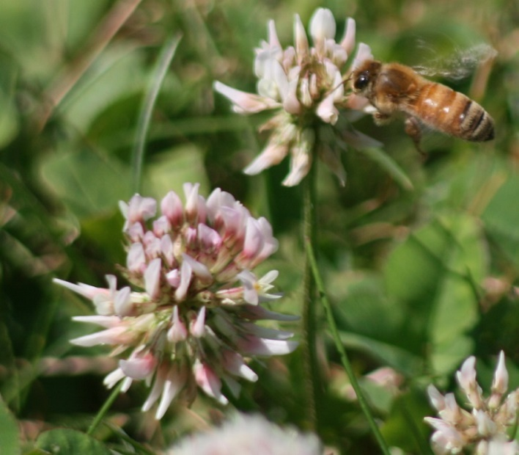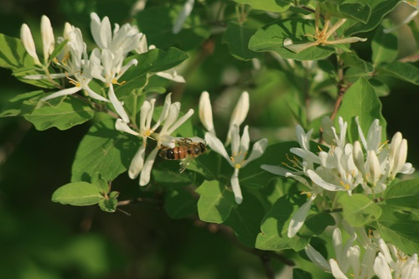
White Clover
Description: low growing, white flowers, usually 3 leaves
Pollinators : nectar source
Source: https://en.m.wikipedia.org/wiki/Trifolium_repens

Honeysuckle
Description: arching shrub or twining vine, tubular, fragrant flowers
Pollinators : nectar source

Source: https://en.m.wikipedia.org/wiki/Caprifoliaceae

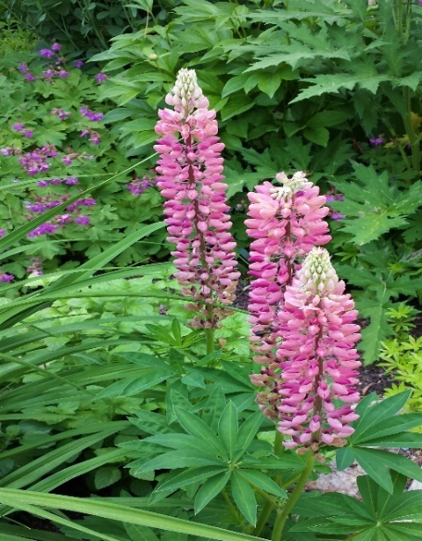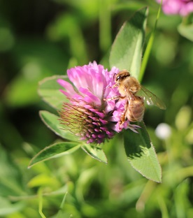
Lupine
Description: spike, whorls of flowers, palmate leaves, multi-colors
Pollinators : nectar & pollen source

Source : https://en.m.wikipedia.org/wiki/Lupinus
Red Clover
Description: trifolate, dark pink flower, lighter at base
Pollinators : Nectar source
Source: https://en.m.wikipedia.org/wiki/Trifolium_pratense

