NH-is-Blooming Observation Instructions
- Each month we will send you an observation “package” which identifies four or five pollinator friendly flowers that we would like you to watch for anywhere you happen to be around NH.
- When you see one of the flowers, record it on the observation sheet by noting the date, town, and whether you saw pollinators on the flowers.
  - If you see other flowers with pollinators, feel free to also record that on the observation sheet.
- At the end of the month, you can send your observation sheet via either email to nh.is.blooming.com or by USPS mail at: NH-is-Blooming, PO Box 250, Gilmanton, NH 03237.
  - We will add it to the NH-is-blooming database soon after we receive it.
  - We are happy to accept the observations in any format that is easy for you!
- Send questions to: nh.is.blooming@gmail.com

NH-is-Blooming September Observation Flowers
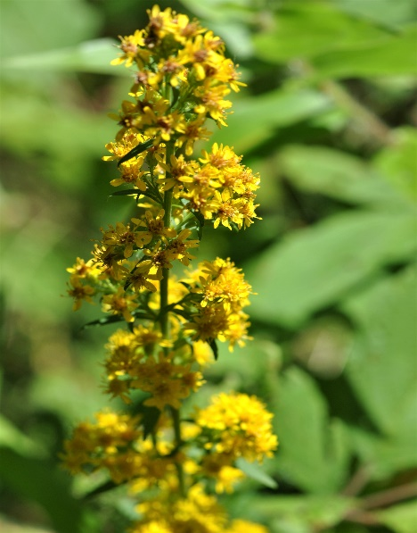

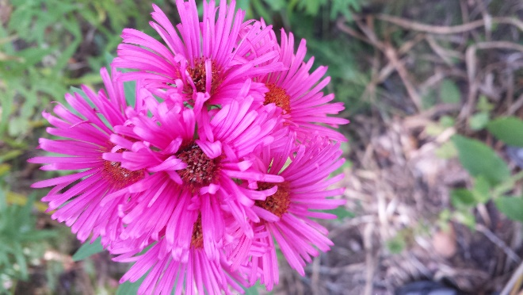

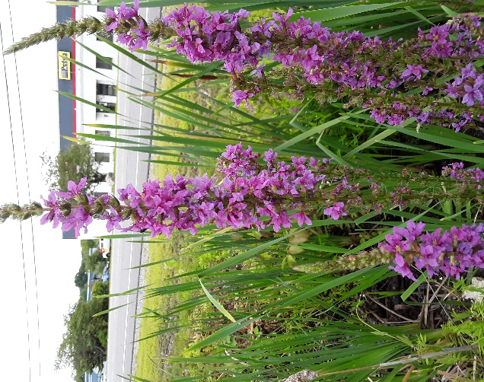
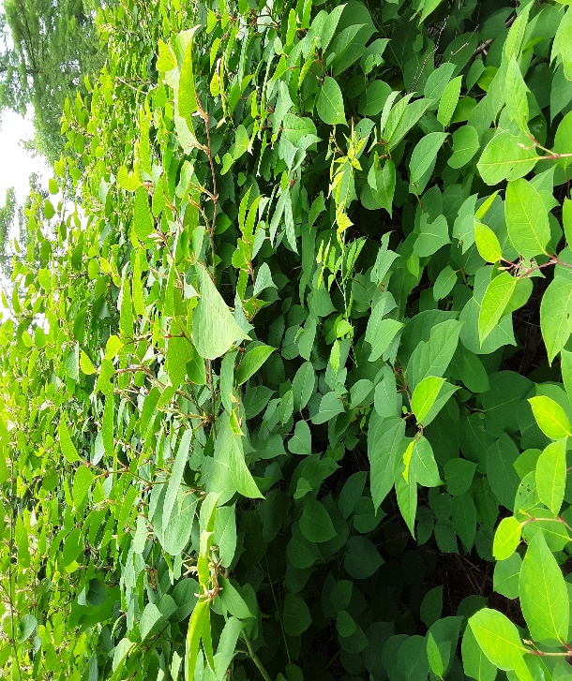
Aster
Description: many species, star like flowerheads, many colors, small shrub like plant
Pollinators : pollen and nectar source

Source: https://www.almanac.com/plant/asters

Knotweed
Description: white or pale green flower clusters, 3”-4”long. Spade shaped leaves
Pollinators : nectar & pollen source
Source : https://extension.psu.edu/japanese-knotweed#:~:text=Knotweed%20is%20a%20highly%20successful%20invader%20of%20wetlands%2C,hybrid%20bohemian%20knotweed%20%28%20Fallopia%20%C3%97%20bohemica%20%29.
Loosestrife
Description: square stems, narrow leaves, spikes of star shaped flowers
Pollinators : pollen and nectar source

Source: https://en.wikipedia.org/wiki/Lythrum
Goldenrod
Description: yellow, slim spike
Pollinators : pollen and nectar source
Source: https://plants.usda.gov/core/profile?symbol=SOLID

